**Conference for Young Writers**

January 7, 2025

Student and Adult Survey



**Name & School Name Optional:**

**Select One**

Student  Adult

1. **What grade are you in? (Students select One)**

K  1  2  3  4  5  6  7  8

1. **Tell us how much you liked the Keynote Presentation:**

 ✰1 ✰2 ✰3 ✰4 ✰5

1. **What did the Keynote Presentation teach you?**
2. **Did you explore and learn something new at the conference?**

Yes  No

1. **Select the three sessions you were in:**

|  |  |  |  |  |
| --- | --- | --- | --- | --- |
| A. Plotting with Post-its | B. How to Write Fantasy, Myster, Anything | C. Create Tall Tales | D. Explore the Magic of Imagination | E. Character Sketch |
| F. Writing TV News in an Hour | G. Retold Fairy Tales | H. Midnight, The Darkest Part of the Night to Write | I. The Art of Rap | J. Escape the Cold; Go to the Garden! |
| K. Sing a Story | L. Deadline: News Desk |  |  |  |

1. **Which session was the most fun?**
2. **What made this session fun?**
3. **What did you learn?**

Flip Over

1. **Students and Adults: Would you attend the Young Writers Conference again?**

Yes  No  Maybe

1. **Adult: How has this experience influenced your student(s)?**
2. **Additional comments about the conference:**
3. **Suggestions for future topics, speakers, etc.**

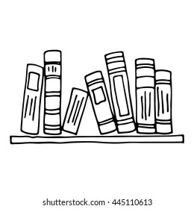

**Contact: Andrea Anderson,**

**Student Enrichment Coordinator**

507-537-2257

www.swwc.org/ya

[andrea.anderson@swwc.org](mailto:andrea.anderson@swwc.org)

